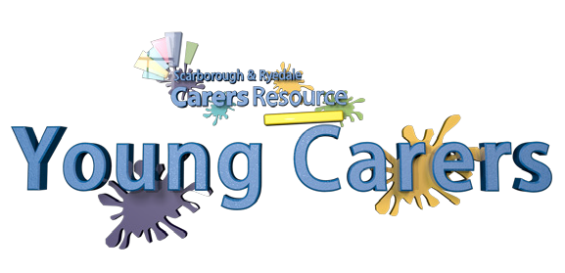Young Carers Western Australia & Young Carers Scarborough & Ryedale Carers Resource, United Kingdom
Pen Pal Program

Expressions of interest are now being taken for young carers that would like to become pen pals with a young carer in the United Kingdom/Western Australia.
Your name here Age Gender
For Under 18’s, Parents/Guardians will be asked to accept and acknowledge guidelines when giving consent for their child to participate in the program.
Matching Process
Pen pals should begin by sharing a bit about themselves and asking a question of their pen pal. Here are some ideas you can tell your potential pen pal about:
Your family and where you live:

Your pet/s:

Your school and/or favourite subjects: Your favourite activities, books, or movies:
Your hopes and dreams:

Your question to your potential pen pal:
Disclaimer/Guidelines
Parents/Guardians are responsible for the nature of the content in their child’s letters. We expect that participants will converse with respect at all times, and will not submit false, misleading, or inaccurate information pertaining to their identity. Parents/Guardians can be involved in the letter writing process and should set clear content expectations with their child before beginning the program. We suggest parents of matched participants share an introductory letter as well. Should any participants decide to exchange social media links as a result of the program, this should be done with parental consent and the organisations accept no liability.
I, Parent/Guardian Name agree to the above guidelines.
Date

